Android Developer Candidate Test

Introduction

This test is based on the famous Flickr photos sharing service. This is possible by using the public Flickr API. Your task is to write an Android app that mainly fetches photos through a REST Api.

Use this link for more information how to use the Flickr API. https://www.flickr.com/services/api/

Requirements

* Write an Android app according to the following specifications. Users of your app should be able to fetch photos by searching for any particular keyword.
* Show the photos in a RecyclerView including the title on each cell.
* When the user tap on any of the selected photo (cell) a new RecyclerView should be showed listing  more photos for that particular user.
* Implement a caching solution so when the same search keyword is used the data is retrieved from the  cache.
* The UI should be compatible with Common Android Screen sizes
* As a Bonus task you should setup two different targets in the app. Come up with a solution that makes  it possible to use different style on one of the targets. (i.e. Changing Colors).
* The Solution should support Android 4.0+

UI Guidelines

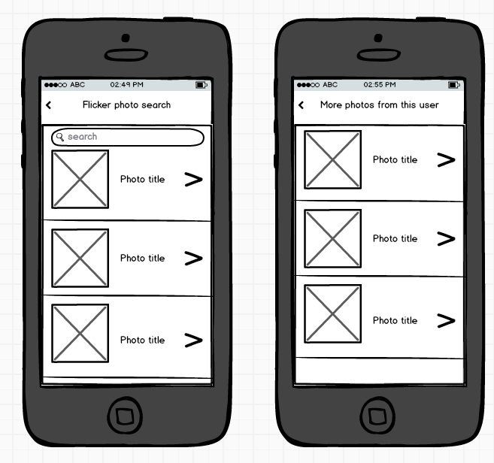

Our Expectations

Through this programming test, you should be able to demonstrate:

* Good understanding of core Android concepts and technologies, the Java programming language, how to construct a UI and how to organize code with MVC pattern.
* Use Gradle for your app, add Volley framework as a dependency and use it for networking functionality.
* Code Quality and maintainability.
* Good programming practices.
* We do NOT focus on the beauty of the UI, but we expect efficient and responsive app.

Deliverables

* 1. Android studio Project  uploaded to a GIT server of your choice
  2. If you used any external libraries, make it clear in your submission’s readme file.